**Care of briquettes**

**INSTRUCTION TO THE PATIENT UNDERGOING TREATMENT OF BREKET-SISTEMOY**

**1. Accustoming to breket-system**

At once after emergence in a mouth of briquettes, you will feel a little unusually. Don't worry – these feelings will pass soon, and you in general will forget about briquettes.

In the first days after bracing of briquettes (usually 3-7 days) there can be some discomfort or pain in teeth. They are very individual and at different patients can be expressed in various degree. On average a case teeth ache by the evening about 3-4 days, the morbidity as much again remains at a nakusyvaniye. If the aching pain prevents you to fall asleep, it is possible to use anesthetics. We recommend Nise (Nimesulide, I nimesit) – on 1 tablet 2 times a day or only for the night, no more than 5 days. At a traumatizing mucous cheeks and labiums briquettes apply special protective wax. Stick with it briquettes if they rub cheeks, labiums, tongue. It is possible to use conditioners like "Tantum Verde". On the injured site of mucous to apply Metrogil-Denta gel.

**2. Hygiene of an oral cavity**

Toothbrushing - one of the most important elements of a complex of actions for care of an oral cavity. The remains of a nutrition and a debris are the main responsible in formation of caries. Teeth it is necessary after each meal in front of the mirror, using at the same time special agents of hygiene.

Will be necessary for toothbrushing:

1. Usual toothbrush

2. Orthodontic toothbrush (Oral-B Ortho)

3. A brush with special brushes and a set of brushes to it.

4. Monofascicular toothbrush

5. Floss

6. Irrigator

1. It is necessary to clean the surfaces of teeth by means of the toothbrush having a V-shaped cut on the surface of a bristle after each meal. At first Ortho you brush the external surface of teeth on which briquettes fasten, making the horizontal movements along all arch of breket-system, then you pass to a mandible.



Cleaning continuation — as usual when on teeth there are no briquettes. You hold a brush at an angle 45 ° to a gingiva and you clean the sweeping-out movements from an internal surface (lingual and palatal) teeth. Clean a chewing surface of teeth.

2. The brush consists of the handle and removable heads which change in process of wear. To them clean the surface of tooth and a briquette from four parties.



3. A monofascicular brush — an excellent agent for cleaning of remote surfaces of teeth. The brush has only one fascicle of very soft bristle, and each tooth is cleaned separately. The fascicular brush in combination with brushes, provides complete control of a debris.

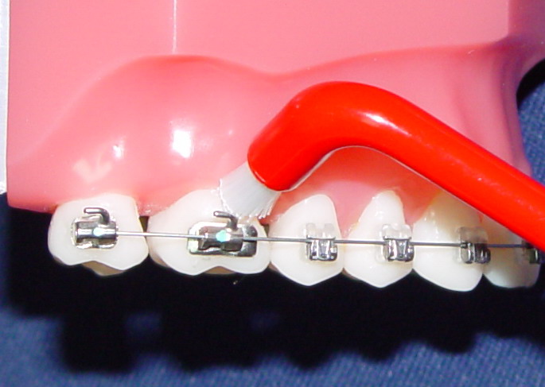

4. Clean interdental spaces by means of a dental floss, watching that thread slipped on the surface of tooth all the time, without injuring a gingiva.

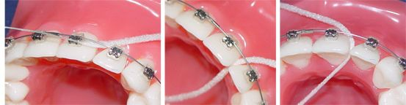

5. For the best hygiene use an irrigator for an oral cavity, it will significantly facilitate your task of cleaning a briquette — systems.

In it the water pumped under pressure to promote cleaning around briquettes and along the line of gums is used. As an alternative to water in it mouthwash can be used.

After cleaning to a propoloskayta of companies and brush warm water. Look in a mirror — whether any places are passed. If you noticed that you somewhere passed, then don't postpone for the following time, and repeat cleaning at once. Be especially attentive and careful, cleaning spaces between briquettes and a gingiva.

When you finished cleaning — teeth, briquettes, rings and arches have to shine! Toothpaste has to be foamy to get into all hard-to-reach spots of an oral cavity. If there is no opportunity to clean teeth after meal it is necessary to rinse a mouth well.

**3. Restrictions in a delivery**

For the period of baking it is necessary to refuse the use:

1. Sticky products (toffee, toffees, chewing gum, wafers, chips, halvah

2. Firm products (nuts, candies with nuts, dryings, bagels, crackers).Firm vegetables and fruit, such as carrots, apples, pears, it is impossible to bite off, they are cut on small pieces. It concerns also tough meat and any products demanding nibble.

3. Arches are thermoactive therefore it is necessary to exclude too cold and too hot nutrition and also transition cold – is hotter since arches can burst and their replacement is required.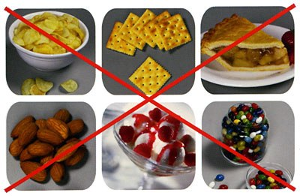

***Failure to follow these references leads to unsticking of briquettes. Otkleyka of briquettes can lead to elongation of terms of treatment.***

**4. Possible breakages**

When keeping references of breakage and an otkleyka of briquettes happen seldom. Nevertheless, they are possible. In case of unsticking of a briquette (the briquette isn't densely fixed to tooth, slips on an arch) it is necessary to call the administrator. ph. 8 (4712) 54-02-02 to report about unsticking of a briquette and to register in reception.

In case of any inconveniences, the doubts bound to treatment process you can always call clinic in day of work of the orthodontist and ask any interesting questions.

**At visit of the orthodontist it is necessary to come to reception with well cleaned teeth. If at you wasn't for this time, then bring a toothbrush with yourself and clean teeth in our clinic before visit.**

**Happy journey to a beautiful smile!!!**

